# INTRODUCTION

#### **1.1 Problem Statement**

The concept of traditional income tax calculation has changed radically within the last couple of years. During the Covid years, the use of income tax calculators increased drastically. It was due to the lack of access to tax professionals during the time. People were not able to calculate their income taxes with ease due to Covid protocols. This is when the idea of online income tax calculation came into existence. Now, you have access to online income tax calculation services whenever and wherever you want, as long as you have access to a computer and the internet. We are now entering a new era, the revolution of online income tax calculation. The purpose of online income tax calculators is to allow people to calculate their income taxes online with ease.

***1.2 Proposed System***

The proposed income tax calculator website aims to overcome the challenges of the current income tax calculation process by providing a comprehensive and user-friendly platform for calculating income taxes. The website will leverage technology to streamline the process, enhance convenience, and optimize income tax calculation accuracy. Key features of the proposed website include:

* Accuracy: The website will be based on the latest tax laws and regulations, ensuring that taxpayers receive accurate estimates of their tax liability.
* Convenience: The website will be easy to use, allowing taxpayers to calculate their taxes quickly and easily.

The proposed income tax calculator website will be a valuable resource for taxpayers of all income levels. It will provide a convenient and accurate way to calculate income taxes, saving taxpayers time and money.

In addition to the key features listed above, the proposed website will also offer the following benefits:

* Time savings: Taxpayers will save time by not having to manually calculate their taxes.
* Peace of mind: Taxpayers can be confident that they are paying the correct amount of taxes.
* Improved compliance: Taxpayers who use the website are more likely to comply with tax laws.

The proposed income tax calculator website will be a valuable resource for taxpayers and tax professionals alike. It will provide a convenient, accurate, and reliable way to calculate income taxes.

## ***1.3 Features of the Project***

The features of this website are:

* + - Tax Calculations
    - Report Generation
    - Analytics of Tax reports
    - Tax Savings Guide
    - Tax Slab Rates
    - Mobile Responsiveness
    - User-Friendly Interface.
    - Administrative Dashboard.

# 2. FEATURES AND HIGHLIGHTS

***FEATURES AND HIGHLIGHTS***

1.Users can register and login into the system. 2.Users can calculate Taxes.

3.Users can view different Tax Savings Guide. 4.Users can add Tax Details.

5.User can view their respective Tax details.

6.User can take print of Tax details.

7.The Admin can view

1.The whole Database

2.Tax Calculations

3.Dynamic Elements

8.Admin can add Tax Details.

9.Admin can add User Details. 10.Admin can edit all details.

# 3. TECHNICAL ASPECTS

###### *TECHNICAL ASPECTS*

* Presentation Layer:
  + User Interface (UI): This layer includes the components that interact with users, such as web pages or mobile app screens.
  + Django Templates: Django's built-in template engine allows you to define HTML templates that render dynamic content and interact with the back-end.
  + Jazzmin package: Jazzmin provides a very interactive Django admin panel GUI
  + Chartjs: Javascript library that provides interactive charts for analytics
* Application Layer:
  + Django: Django serves as the back-end framework, handling HTTP requests, routing, and managing the application's business logic.
  + Django Views: Views receive requests from the user interface, process data, and generate appropriate responses. They interact with models, services, and external APIs as needed.

***CLASS DIAGRAM OF DATABASE***

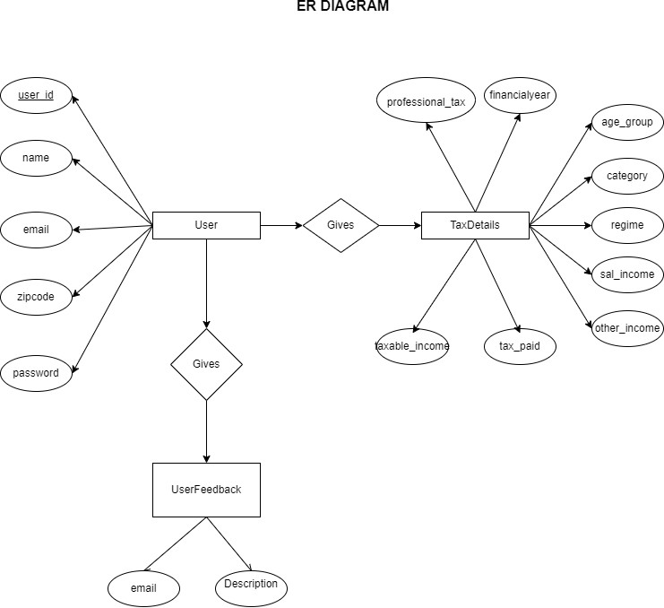

# 4. CHALLENEGES FACED DURING DEVELOPMENT

* User Authentication and Authorization: Implementing a secure and reliable user authentication and authorization system can be challenging. You need to ensure that only authenticated and authorized users can access and perform actions within the reservation system.
* Database Design and Management: Designing an efficient and scalable database structure for Tax calculations can be complex. Plan the database schema carefully, considering factors such as user data, calculation data, Tax slab rates, and Savings Guide. Use appropriate indexing and caching techniques to optimize database performance.
* User Experience and User Interface: Designing an intuitive and user-friendly interface for calculating income tax can be a challenge. Conduct user research, gather feedback, and iterate on the user interface to provide a smooth and hassle-free experience for users. Focus on usability, responsiveness, and accessibility considerations.
* Coding the logic behind Tax calculations were really difficult. It was completed after days of coding and getting help from friends
* Testing and Quality Assurance: Thoroughly testing the Tax calculations to identify and fix bugs, as well as ensuring its reliability, can be a significant challenge. Implementing unit tests, integration tests, and conducting usability testing can help ensure the system functions as expected and meets user requirements.

# 5. FUTURE ENHANCEMENTS

##### *FUTURE ENHANCEMENTS*

* + Mobile Application: Develop a mobile application for the Tax Calculation to allow users to easily Calculate Income Tax, receive notifications, and manage their income and have insights on their mobile devices.
  + Real-Time Availability: Implement real-time availability updates to provide users with up-to-date information on Tax Calculations.
  + Other Tax calculating Options: Other Tax calculating Options such as Sales tax, Deferred Tax Calculator, House Rent Allowance Calculator etc.
* Premium Version : which provides extra features such as tax payment recommendations, analytics

# 6. CONCLUSION

##### *CONCLUSION*

The project was successfully completed within the time span allotted. All the modules are tested separately and put together to form the main system. Finally, the modules are tested with real data and it worked successfully. Thus the system has fulfilled the entire objective defined. Our goal of developing this Income Tax Calculation System has come to a good result without many defects. Tax Calculation system improves the existing system since we are in the computerized world. With this new system is mandatory, it enables the user of the system (commoner, System administrator) to Calculate Income Tax online and this reduces the wasting of time of the clients looking for calculation of taxes, increases the tax payment to the Government since the tax calculator is making them a better citizen. So this system provides all the available best services to all the customers

# 7. REFERENCES

##### *REFERENCES*

* + <https://incometaxindia.gov.in/Pages/default.aspx>
  + <https://groww.in/calculators/income-tax-calculator>

# ANNEXURES

1. *SCREENSHOTS*